**CS3431-A24: Project Description**

**Phase 3: Database Application**

Due Date: Saturday, Oct. 5 at 11:59pm. No late submissions.

Teams: The project is done in the same teams of two as in the previous project phases.

Submission: One teammate will zip the IntelliJ p3 project. If you developed the code using a different IDE, submit the zipped p3.java file. Include both of your names in a comment at the top of your code. Any comments or assumptions that you have, you can include them in a separate Word or PDF file. **Also make sure to use the given interface and filename or the auto-grader will give you a 0**!

Description:

For the first two phases of this term project, you were a database developer in charge of creating the database component that application developers would use. For this final phase of the project, you will get experience from the other side - you are now a Java application developer who will use and modify a database created by someone else for your use.

Download and use the provided p3start.sql file and p3 zipped IntelliJ project to do the final phase of the project. Please keep all your code in a single file strictly for grading purposes (yes, it is ugly but it greatly reduces the work of the TAs), and especially if you are using an IDE other than IntelliJ. The SQL file contains the same starter tables from Phase 2 so you can test your Java code.

You are required to write a java program that accesses and modifies the database, and prints results on the screen. Your program will be the interface to perform some simple functionality over the database. **Pay careful attention to the naming of your file and class so we can run the code and give you credit for this final project phase! If your java program does not compile properly, you will receive the grade of 0.**

When the program is run without any parameters, display the message:

“You need to include your UserID and Password parameters on the command line”

The program will take two parameters, e.g., username and password to connect to the DB. (Pass them as parameters such that the TAs can easily set them as needed without recompilation).

When your program is executed without any additional arguments, e.g.,  
> java p3 <username> <password>

Then the program should output the following options, and then terminate:

Include the number of the following menu item as the third parameter on the command line.

1 – Report Member Information

2 – Report Customer’s Rank List Information

3 – Update Member Level

1. When the program is executed with an argument 1 as follows:  
   > java p3 <username> <password> 1

The program now enters the “Member Information” mode. The program should print out the following line:

Enter Member’s email address: <and wait for user’s input>

When the user enters the member’s email address, the program should execute a query and print on the screen the following member information and then terminate.

Member Information

Name: …

Email: …

Address: …

Member ID: …

Member Level: …

Name should include first name and last name on a single line. Address should include city and state separated by a comma on a single line.

1. When the program is executed with an argument 2 as follows:  
   > java p3 <username> <password> 2

The program enters the “Rank List” mode. The program should print out the following line:

Enter Customer Email: <and wait for user’s input>

Enter Year: <and wait for user’s input>

When the user enters the customer’s email and year of the ranked list, the program should execute a query of Ranklist and related tables and print on the screen the following customer’s ranking information as follows:

Customer Rank List

Customer Name: …

Year: …

Rank: …

Artist Name: …

Artwork Title: …

Rank: …

Artist Name: …

Artwork Title: …

* Names should include first name and last name on a single line.
* The ranked artwork should be displayed ordered by rank starting from 1

1. When the program is executed with an argument 3 as follows:  
   > java p3 <username> <password> 3

The program now enters the “Update Member Level” mode. The program should print out the following line:

Enter the Member’s ID: <and wait for user’s input>

Enter the Member Level: <and wait for user’s input>

Then your program should update the member level in the Member table. If you execute option 1 again with the email address for this member ID, you should get the updated membership level.

You will want to use IntelliJ run configurations to specify the parameters so you do not have to type the command line over and over again.

In the p3 IntelliJ project, click on the dropdown arrow to the left of the green run button on the top menu.

Select Edit Configurations

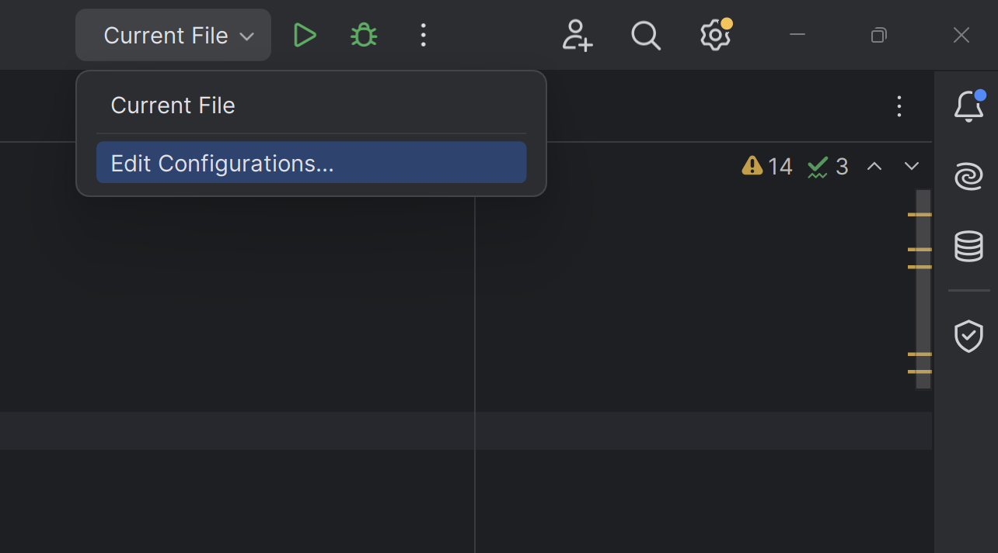

1. Click on the + and select Application.
2. Create a run configuration for the first option, Member Information.
3. Enter p3 1 for the name.
4. Select jbr-17 for Build and Run.
5. Click on the button on the right of Main Class and select p3.
6. For program arguments, enter your ACTUAL username, password and the option 1

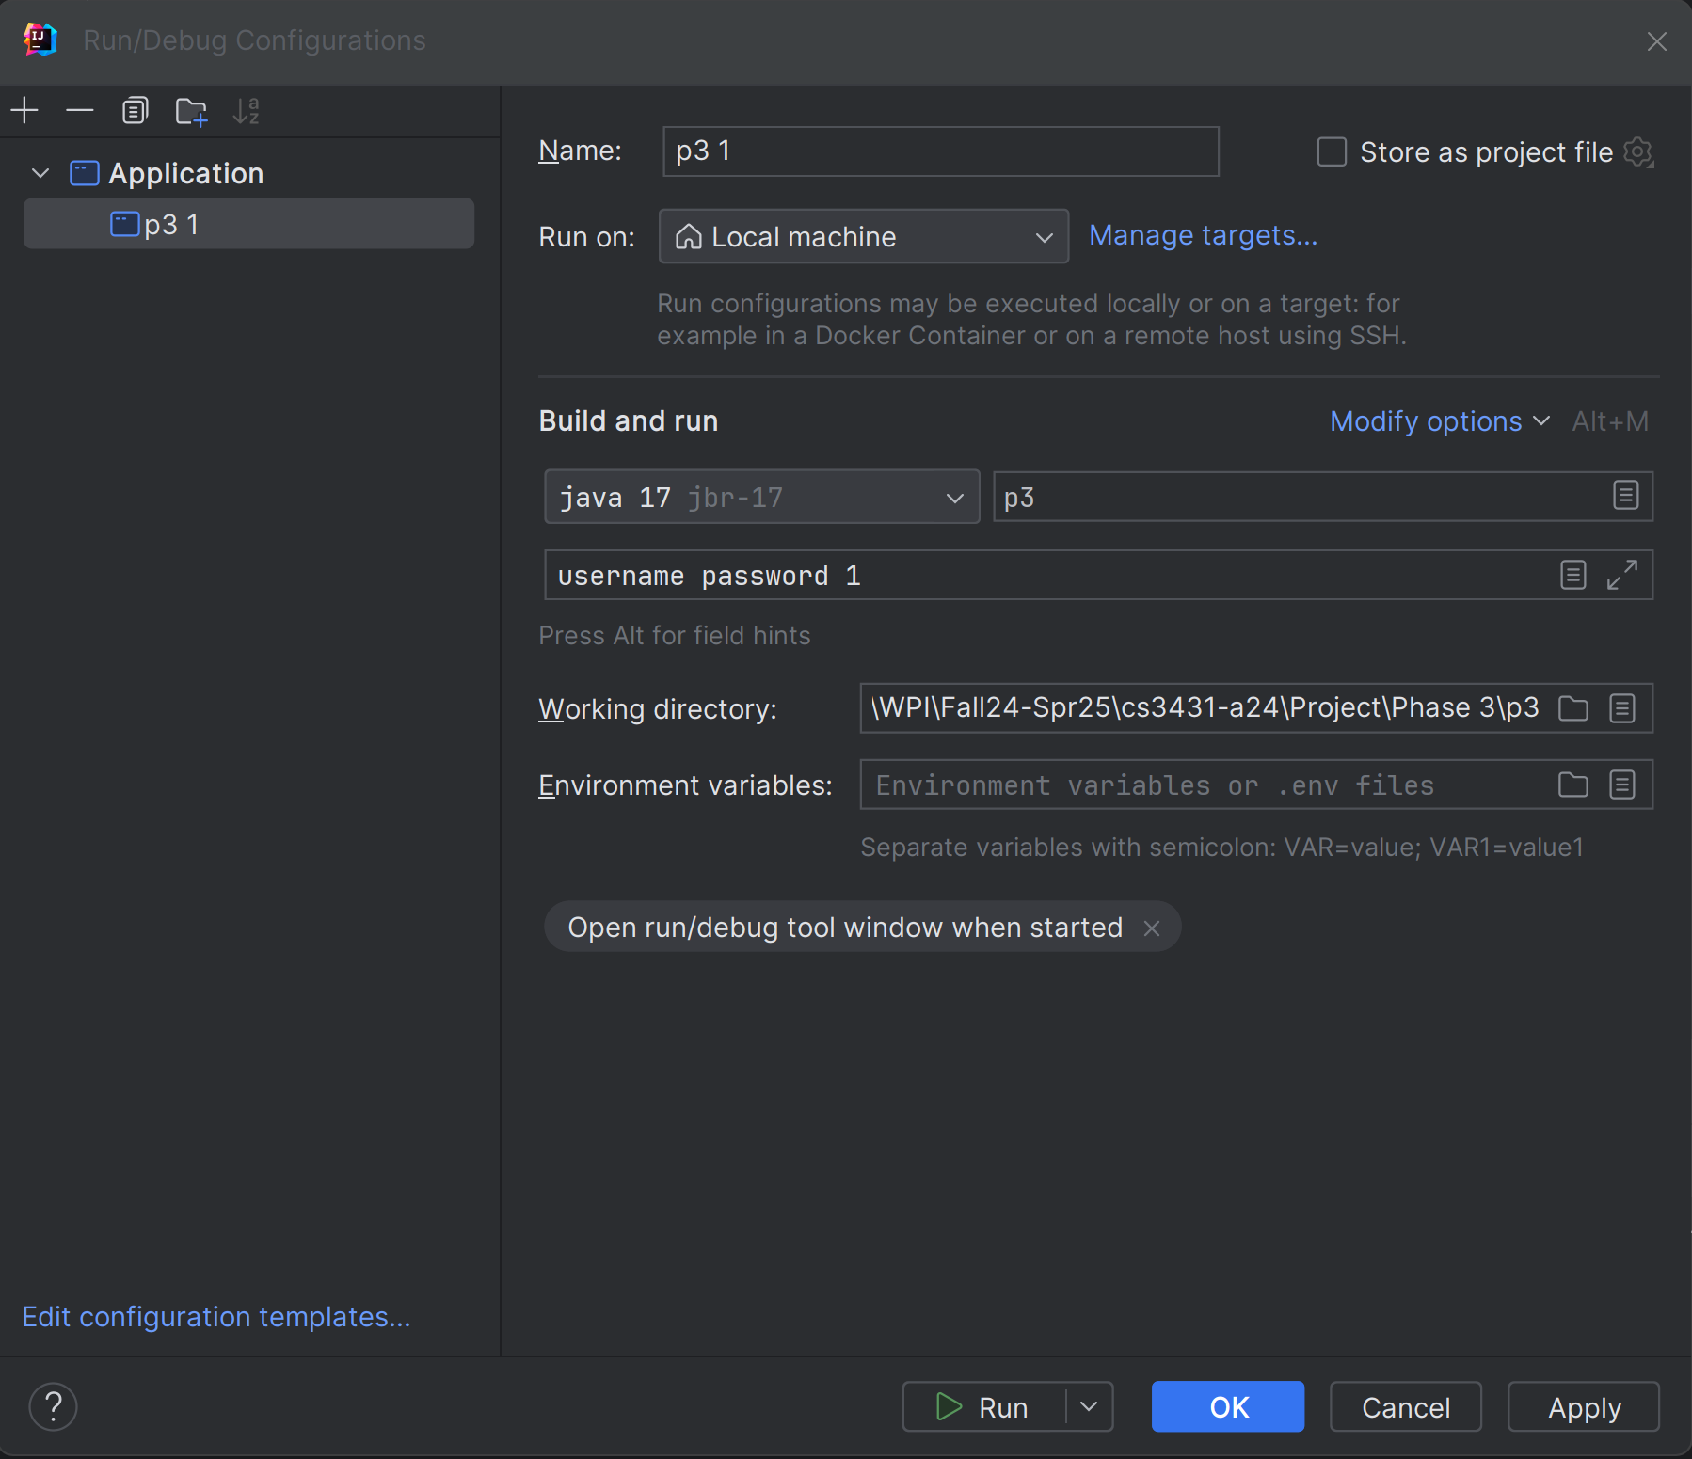

Create run configurations for options 2 and 3.